(TBC) Title: Predictive Modeling of COVID-19 Variant Peak Prevalence and Duration Using GISAID Data Across 15 Countries

Abstract
Background. Effective surveillance of SARS-CoV-2 variants is crucial for timely public health responses. we developed an early‑warning framework that turns the first 2–5 weeks of GISAID lineage–share data into forecasts of a variant’s future domestic dominance.
Methods. Based on GISAID genomic data from 15 high-sequencing countries, we trained a suite of machine learning models on early variant trajectories (14–35 days), combining epidemiological features and statistical descriptors from the catch22 library. Predictions focused on two complementary outcomes of dominance: monthly peak share and duration of sustained circulation above a 10% domestic share. Model performance was evaluated using RMSE and R² for peak share, and accuracy and macro-F1 for duration. To enhance interpretability, we applied SHAP analysis to quantify the global and local contributions of predictors, highlighting key early signals of variant dominance.
Results. Models showed strong efficiency in predicting variant dominance: Cubist and SVM achieved the lowest errors for monthly peak share (RMSE ≈ 0.10, R² > 0.70), while Elastic Net provided the best performance for duration above 10% share (accuracy ≈ 0.70, macro-F1 ≈ 0.68). Prediction improved with longer early-stage inputs, though performance varied across countries, with higher accuracy in well-sampled settings and reduced efficiency in irregularly sampled ones. Across both outcomes, early peak value, non-zero counts, and cumulative presence (AUC) emerged as the most influential features, underscoring the importance of intensity and persistence signals in shaping dominance trajectories. (here you may highlight the best performance countries which our model works with quantitative uncertainty ranges across countries)
Conclusion. This framework enables identification of dominant SARS-CoV-2 variants approximately one month before peak prevalence, providing actionable intelligence for public health decision-making. The methodology offers broad applicability for respiratory pathogen surveillance, potentially enhancing pandemic preparedness through early detection of emerging threats and optimized resource allocation strategies.

Introduction.
The SARS-CoV-2 pandemic has provided a unique opportunity to observe viral evolution and competition in real time, offering insights into broader respiratory pathogen dynamics (Harvey et al., 2021). As variants have demonstrated clear patterns of emergence, dominance, and replacement, this viral succession has created a natural experiment in pathogen evolution. Identifying early indicators of dominance carries profound implications for public health planning, including vaccination strategies and resource allocation. Consequently, global health organizations like the Centers for Disease Control and Prevention (CDC) and the World Health Organization (WHO) have emphasized that SARS-CoV-2 variant surveillance remains critical for pandemic preparedness.
Despite the global experience of multiple SARS-CoV-2 infection waves, however, timely identification of variants likely to drive new waves remains a significant challenge due to several complex factors. The rapid mutation rate of SARS-CoV-2 results in a diverse and evolving pool of variants, each with unique genetic profiles that can influence transmissibility, immune evasion, and disease severity. This diversity complicates the ability to distinguish which variants, especially those at low prevalence (e.g., 0.01–3%), have the potential to dominate and trigger significant outbreaks. The challenge is compounded by variability in sequencing capacity across countries, with low-resource settings often facing delays in generating sufficient genomic data to detect emerging variants early. For instance, while high-sequencing settings (~1,000 sequences/week) enable robust monitoring, regions with limited infrastructure (~100 sequences/week) struggle to provide timely data, delaying detection and response. Additionally, the interplay of epidemiological factors—such as population immunity, vaccination coverage, and non-pharmaceutical interventions—varies widely across countries, affecting variant spread and dominance patterns. These factors create heterogeneous epidemiological contexts, making it difficult to generalize predictive models globally. Existing models (e.g. CDC’s 2-3 weeks variant proportion forecasts using nowcasting approaches), while effective for short-term forecasts, often lack the lead time needed to anticipate long-term shifts driven by rare or novel variants. For example, unsupervised models like DeepAutoCoV can provide 4–17 weeks of lead time for detecting potential dominant lineages, but their performance depends on consistent sequence availability and may falter in data-scarce regions. Furthermore, integrating real-time data on human behavior, mobility, and policy changes into predictive frameworks remains challenging, as these dynamics can significantly alter variant trajectories. For instance, frameworks like Bi-LSTM incorporate mobility and policy covariates but are typically limited to short-term predictions (Ben Said et al., 2021). The unpredictability of variant emergence also stems from the potential for novel mutations to confer unexpected advantages, such as enhanced receptor binding or immune escape, which are difficult to predict without detailed biological data. While models like PyR0 account for viral biological attributes, they are less effective at anticipating entirely new variants.
As an early warning system, we developed a scalable predictive framework for SARS-CoV-2 variant dynamics, as sequence-only models that can rapidly analyze early growth trends without relying on extensive biological or epidemiological inputs. Based on comprehensive genomic data from the Global Initiative on Sharing All Influenza Data (GISAID), we analyze lineage dynamics across 15 high-burden countries from January 2020 to May 2024, addressing two fundamental questions: which variants emerge to dominance and how long they sustain it. Leveraging this large dataset, we characterize cross-country patterns of variant emergence and dominance, process raw lineages into grouped analytical units to isolate dominant signals and establish outcome definitions that capture two complementary aspects of dominance: monthly peak share and duration of circulation above 10% share. To support predictive modeling, we generate early-stage features from 2–5 weeks of observation, combining manually calculated epidemiological indicators with standardized statistical descriptors, thereby constructing inputs that are informative for a wide range of machine learning approaches.

The principal contribution of this study is a systematic comparison of the suitability and predictive performance of multiple machine learning models in capturing lineage dynamics across countries. We quantify model performance in predicting both peak intensity and duration, identify the most accurate and stable methods for each outcome, and evaluate their robustness across diverse national settings. To enhance interpretability, we further apply SHAP (Shapley Additive Explanations) analysis to disentangle the relative importance of early features and to illuminate which signals are most predictive of dominance. These findings not only advance methodological approaches for genomic surveillance but also provide a reference framework for anticipating the emergence and persistence of future SARS-CoV-2 variants.

Methods

- Data source. Genomic data for this study were obtained from GISAID (https://www.gisaid.org/) (1). Established in 2017 as the Global Initiative on Sharing All Influenza Data and later expanded with its EpiCoV repository to include SARS-CoV-2 sequences, GISAID now provides access to millions of viral genomes complete with collection dates, geographic origins and sequencing-platform metadata—enabling robust comparative analyses and predictive modeling. We analyzed the 15 countries that had reported the largest number of SARS-CoV-2 sequences as of 19 March 2022, together representing 9.0 million of the 9.5 million sequences in GISAID. Among these, the United States leads with 2.9 million sequences, while Luxembourg contributes the fewest (25 000). Following the WHO/CDC-endorsed Pango lineage nomenclature (20), we identified 1151 distinct variants across these countries, with a median of 72 variants per country (Q1 = 57, Q3 = 121; see Table S1).

Sample Collection and Definitions. The GISAID COVID-19 collection serves as a vital global repository for SARS-CoV-2 genomic data, enabling researchers worldwide to track the virus's evolution, transmission, and mutations. Since its launch in January 2020, GISAID has been regularly updated with submissions from various countries, showcasing collaborative efforts in combating the pandemic. We selected the United States, the United Kingdom, and South Korea as case examples for our analyses, as all three maintained established genomic surveillance programs yet represent diverse epidemiological and health system contexts. Data is collected through a network of participating laboratories, public health institutions, and universities, where clinical samples are sequenced and analyzed before being uploaded to the platform. Institutions such as the Korea Disease Control and Prevention Agency (KDCA), the UK Health Security Agency (UKHSA), and the Centers for Disease Control and Prevention (CDC) in the U.S. play pivotal roles in their respective countries' contributions. GISAID remains a cornerstone of international cooperation, fostering transparency and accelerating research aimed at understanding and mitigating the global impact of COVID-19.

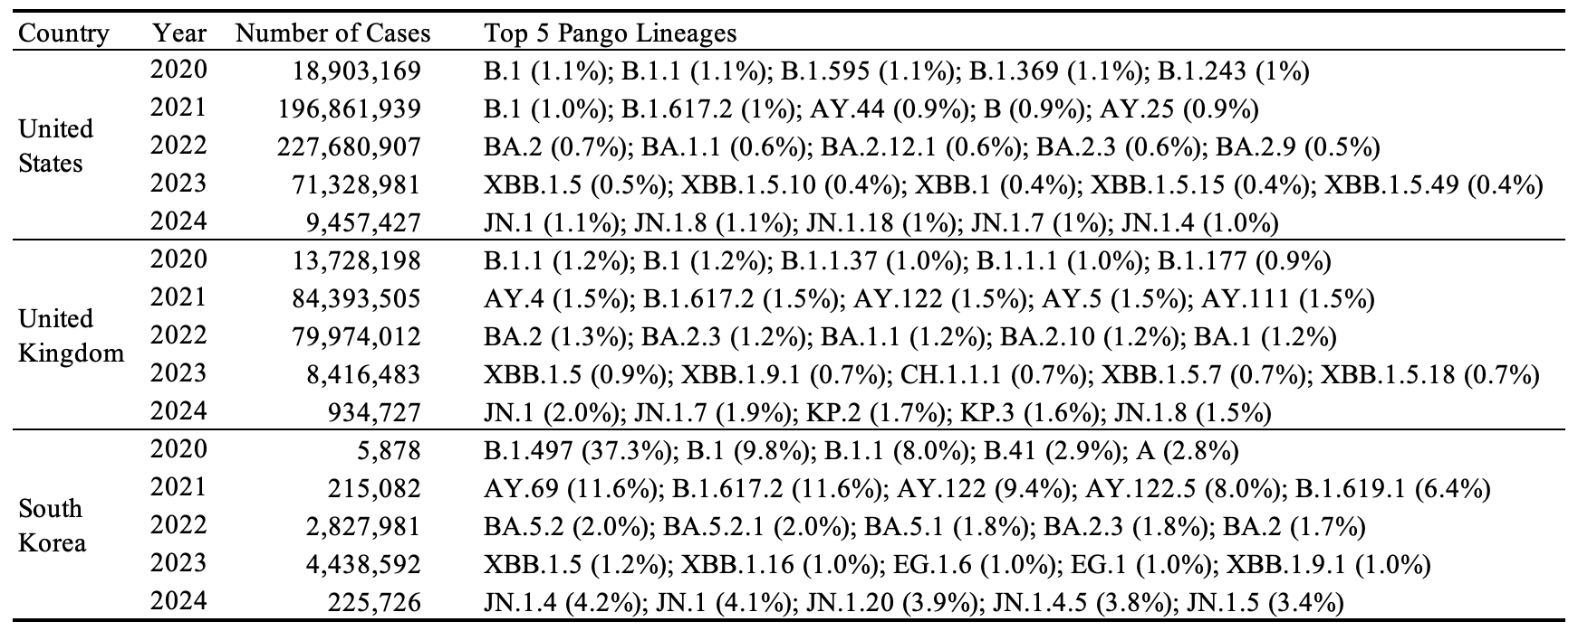
Table 1. Descriptive summary of GASID data showing the distribution of raw PANGO lineages in the United States, the United Kingdom, and South Korea.

The GISAID dataset analyzed here spans daily infection counts for over 3,000 SARS-CoV-2 lineages from January 2020 to May 2024, focusing on the 15 countries with the largest number of cumulative case counts to ensure comprehensive genomic coverage. Table 1 presents the selected country’s annual case totals (2020–2024) alongside its top five lineages, revealing that the United States and United Kingdom differ substantially from South Korea in both year-by-year case distributions and dominant variants—most strikingly in 2020—underscoring the heterogeneous nature of early pandemic dynamics across regions.

- Data processing
Our model is motivated by the need to understand whether early characteristics of emerging SARS-CoV-2 variants can predict their eventual dominance—defined in terms of both peak prevalence and epidemic duration—at the national level. Specifically, we seek to determine whether information from the initial growth phase of a variant’s spread, captured through national-level share trajectories, can forecast how dominant the variant will become in each country. In this framework, peak is defined as the highest monthly domestic share attained by a variant, whereas duration denotes the period during which the variant sustains a domestic share exceeding 10%. This decomposition is grounded in prior work such as [1], who defined lineage establishment based on a minimum of 10 sequenced cases over 14 days, indicating sustained local transmission. We extend this idea to model and quantify variant-level dominance across countries. An overview of the data processing workflow is presented in Figure S1.

Stage 1: Analytic period---exclusion/inclusion variants
To ensure the reliability of these national-level share estimates, we first identified valid analytical periods for each country, using sequencing coverage standards recommended by the World Health Organization [2]. A valid period was defined as a continuous stretch of at least three calendar weeks, each containing at least 100 sequences and four days with non-zero sampling. This ensures that early growth patterns and peak prevalence estimates are derived from consistent, representative data. Following Chen et al. (2022) [3], who showed that sparse sampling introduces significant noise and bias, we retained only those variant–country combinations whose entire observed share trajectories fell within valid periods. These limitations in temporal sequencing coverage have been similarly noted in WHO surveillance guidance [4], variant tracking literature [5].

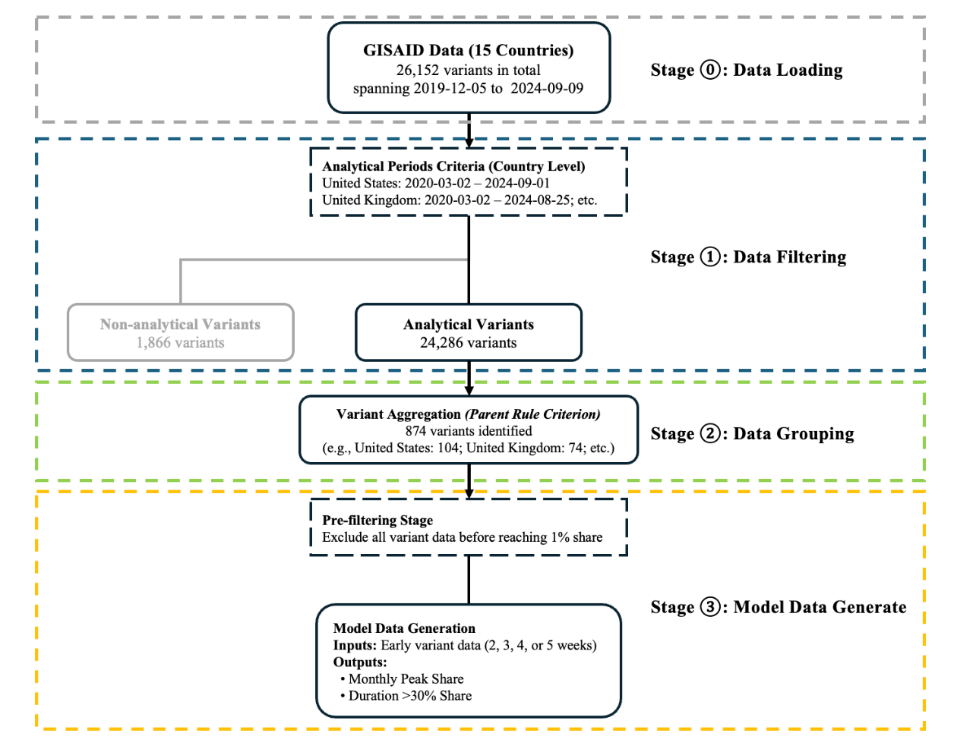
Figure S1. Overview of the data processing workflow, including data inclusion, exclusion, and grouping steps.

As illustrated in Appendix Figure S3, the analytical windows varied considerably across the 15 study countries, reflecting differences in sequencing intensity, reporting continuity, and data quality. For example, countries with consistently dense genomic surveillance such as the United Kingdom and the United States retained nearly the full period from early 2020 through mid-2024, whereas others such as Denmark and South Korea had more truncated windows beginning in mid-2021 or early 2021, respectively. These restrictions ensured that downstream estimates of variant dominance and persistence were not distorted by gaps or artifacts in the underlying sequence data. Before applying this exclusion, a total of 26,152 lineages The suggested criteria on analytic period excluded 1,866 variants (approximately 7%) out of 26,152 lineages. Representative high-volume variants excluded through this process are illustrated in the Appendix. This filtering step led to the exclusion of several variants in countries such as the United Kingdom, Sweden, the United States, Japan, Denmark, and South Korea, where early- or late-stage sampling did not meet the minimum sequencing criteria.

To facilitate robust prediction of variant dominance and reduce data sparsity, we grouped 874 variants out of 24,286 SARS-CoV-2 lineages fully included within the country analytical period into broader variant categories according to their parent lineages and phylogenetic relationships. To maintain analytical relevance, we consolidated 24,286 SARS-CoV-2 lineages into 874 grouped variants, retaining only those with ≥500 cumulative infections by August 2024; lineages that fell below the threshold value were defined as “others”. This classification consolidates highly granular lineage data into a tractable number of epidemiologically meaningful groups. The grouping procedure was applied independently for each country to account for geographic heterogeneity in variant circulation. Figure 2 illustrates the evolving landscape of SARS-CoV-2 variants in the United States, the United Kingdom, and South Korea. In each panel, the light gray “others” category represents the aggregation of numerous lower-prevalence lineages, whose cumulative frequency fell below the threshold required to constitute a meaningful signal. The United States panel highlights successive waves of Delta, early Omicron sublineages (e.g., BA.1/BA.2), and more recent XBB- and JN.1-derived lineages, reflecting a broad and continuous turnover. The United Kingdom is dominated by rapid expansions and replacements of major lineages, notably AY.4 (Delta), BA.2, and subsequent XBB-descended variants, with pronounced peaks and sharp declines. In South Korea, where surveillance began later, the distribution is truncated to its study window; here, BA.2.3-derived sublineages and later JN.1 variants emerged as predominant drivers of transmission. These groupings follow the hierarchical lineage nomenclature of Rambaut et al. [6] and O’Toole et al. [7], facilitating standardized genomic surveillance and comparative epidemiology.

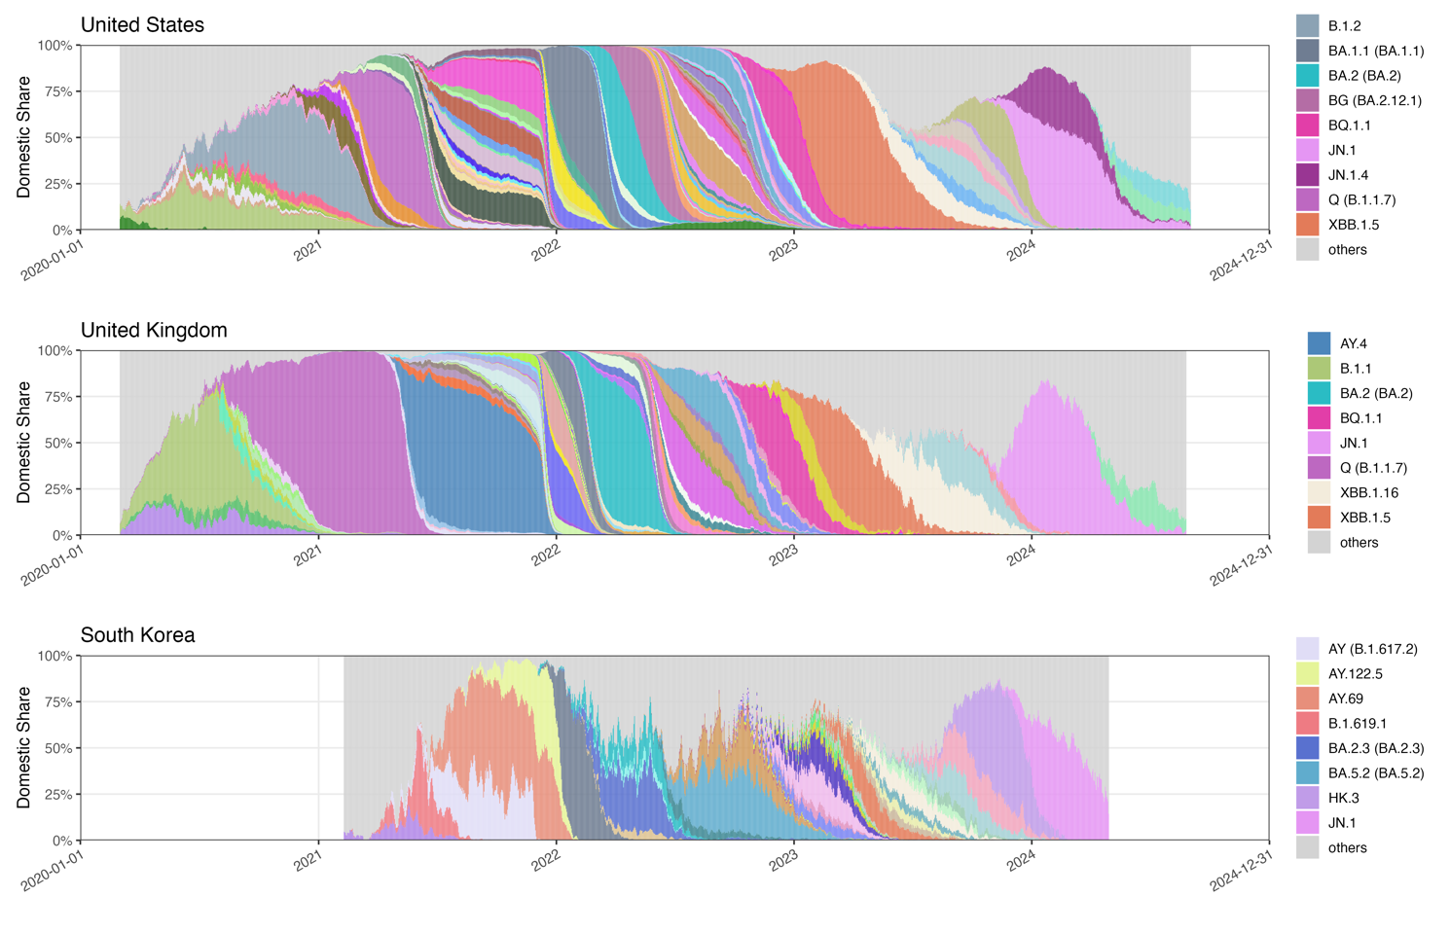
Figure 2. Time-series distribution of SARS-CoV-2 PANGO lineages during the analytical period in the United Kingdom, the United States, and South Korea. Only lineages with monthly maximum share > 30% and > 10% share sustained for > 100 days are shown in the legend.

Stage 3: Outcome definition-dominance
To characterize the extent of dominance, we first considered the monthly maximum share (hereafter, monthly peak), defined as the highest proportion of sequences attributed to a variant within a given month. This continuous measure, ranging from 0 to 1, captures the intensity of a variant’s competitive advantage. The distribution, however, is highly skewed, with most variants reaching only very small peaks (median ≈ 0.08, IQR: 0.03–0.20). To stabilize extreme values and avoid predictions collapsing toward uniformly low estimates, we applied a logit transformation with adaptive clamping, which yielded a more balanced distribution (median ≈ –2.5, IQR: –3.4 to –1.4) and improved the robustness of downstream modeling.

The second outcome captures the duration of maintaining dominance, defined as the number of days during which a variant sustained a domestic share above 10%. This measure emphasizes periods of epidemiological relevance rather than the conventional interval between first and last detection. Nearly one-third of variants never crossed the 10% threshold, underscoring their limited contribution to dominance dynamics. To handle this heterogeneity and enhance stability, the measure was discretized into four ordinal categories: 0, 1–30, 31–100, and 100+ days. This representation preserves meaningful contrasts in persistence while reducing sensitivity to minor fluctuations. Peak share and duration above a 10% threshold provide a clearer measure of a variant’s competitive strength and epidemiological relevance than AUC alone, which may be inflated by minimal but prolonged circulation.

Stage 3: Input period and features
To address these two questions, we employed a suite of machine learning approaches to fit predictive models. In tackling the critical issue of predictor selection, we combined manually curated epidemiological indicators—such as log-linear slopes, short-window growth rates, peak value, normalized AUC, longest increasing run, and non-zero counts—with systematic statistical feature extraction using the R package Rcatch22. (Appendix Table XX) For predictor generation, we defined the early stage of variant emergence as a fixed observation window of 14, 21, 28, or 35 days, corresponding to two to five weeks of daily data. The resulting raw inputs therefore consist of sequential share trajectories of length 14–35, depending on the chosen window. To avoid confounding early predictors with signals of established dominance, we excluded variants whose domestic share exceeded 20%—approximately the third quartile of the empirical distribution—within this initial period. Such variants were omitted from peak modeling because their trajectories already reflected high dominance (Table S2). As a result, the number of variants retained for analysis varies slightly across early-stage definitions, reflecting differences in how quickly lineages reached substantial prevalence.

From these early share sequences, we then constructed two complementary sets of predictors. The first comprised handcrafted, epidemiology-motivated features that summarize epidemic growth patterns, including linear and logit slopes, quadratic curvature, maximum daily increase, variance, autocorrelation, time to reach defined thresholds, and doubling time. These were derived using base R functions and custom routines designed to capture salient aspects of transmission dynamics. The second set was drawn from the catch22 library (Lubba et al., Nat. Commun., 2019), accessed via the Rcatch22 package, which provides 22 minimally redundant descriptors of time-series structure such as entropy, fluctuation scaling, and motif frequency. The catch22 features are computationally efficient, robust to short and noisy sequences, and broadly applicable without parameter tuning—an important advantage given the heterogeneity of early trajectories. By combining interpretable, domain-informed measures with standardized machine-learning–oriented descriptors, this approach balances epidemiological interpretability with statistical power and enhances generalizability across diverse variant profiles.

Together, these features quantify each trajectory’s level, variability, early acceleration, and persistence, providing a rich basis for downstream prediction of peak share and time to dominance. We based our summary‐feature approach on established methods for extracting interpretable time‐series characteristics [9] and on prior applications to SARS‐CoV-2 variant growth [10], yielding a compact set of metrics that capture level, variability, early acceleration, and persistence.

Analysis: Model fitting and assessments using machine learning methods

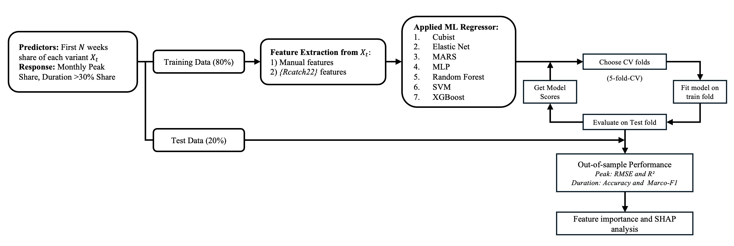
Figure 2. Modeling framework. Variant shares from the first N weeks were used to predict monthly peak share and duration above 10% share. Features included handcrafted and Rcatch22 descriptors. Seven ML regressors were trained with 5-fold CV, with feature importance assessed via SHAP.

To predict the two key outcomes of variant dominance—monthly peak share and duration above 10% share—we employed a diverse set of machine learning algorithms spanning linear, nonlinear, and ensemble approaches. The choice of models was motivated by the structure of our predictors, which combined handcrafted epidemiological features (e.g., growth rates, curvature, doubling times) with a standardized set of statistical descriptors from the catch22 library, derived from early‐stage variant trajectories of 14–35 days. This hybrid feature design balances domain interpretability with statistical flexibility, producing high‐dimensional inputs that require methods capable of handling correlated predictors, nonlinear relationships, and heterogeneous signal strength.

Given our predictors—comprising handcrafted epidemiological features (e.g., growth rates, early peaks, persistence signals) and statistical descriptors from the Rcatch22 library—and our two outcomes, a continuous monthly peak share and a categorical duration measure, we selected a diverse set of machine learning models that are well suited to this structure. Regularized linear methods such as Elastic Net are appropriate for handling correlated, high-dimensional features while retaining interpretability. Rule-based and ensemble approaches, including Cubist, Random Forests, and gradient boosting (GBM/XGBoost), are effective at capturing nonlinear dynamics and interactions that may arise from complex growth patterns. Nonparametric and kernel-based methods such as MARS and SVM are well suited to modeling heterogeneous early trajectories, while neural networks provide additional flexibility for highly nonlinear signals. Together, this collection of models balances interpretability, robustness, and flexibility, and has been widely applied across time-series and epidemiological prediction tasks (Zou & Hastie, 2005; Quinlan, 1993; Friedman, 1991; Hornik et al., 1989; Breiman, 2001; Cortes & Vapnik, 1995; Chen & Guestrin, 2016).

We implemented a structured modeling framework to evaluate the predictive capacity of early variant trajectories. For each variant, predictors were derived from the first N weeks (14–35 days) of share data, and outcome variables were defined as monthly peak share and duration above 10% share. Feature extraction combined handcrafted epidemiological descriptors with the 22 standardized time-series features from the Rcatch22 library (Lubba et al., 2019), ensuring both interpretability and breadth of representation. Performance was assessed separately for the two outcomes to align evaluation with their statistical nature. For the continuous outcome of monthly peak, we used root mean squared error (RMSE) to measure average prediction error and the coefficient of determination (R²) to capture variance explained (James et al., 2013). For the categorical outcome of dominance duration, we reported overall accuracy and macro-F1, where accuracy summarizes the proportion of correct classifications and macro-F1 balances performance across imbalanced classes by averaging precision and recall equally (Sokolova & Lapalme, 2009). To further interpret model behavior, we applied variable importance analysis and SHAP decomposition (Lundberg & Lee, 2017), which together identify key predictors and quantify their contributions at both global and local levels. The entire workflow, from feature extraction to model fitting, evaluation, and interpretation, is summarized in Figure 2.
- Results
Country specific model performance.

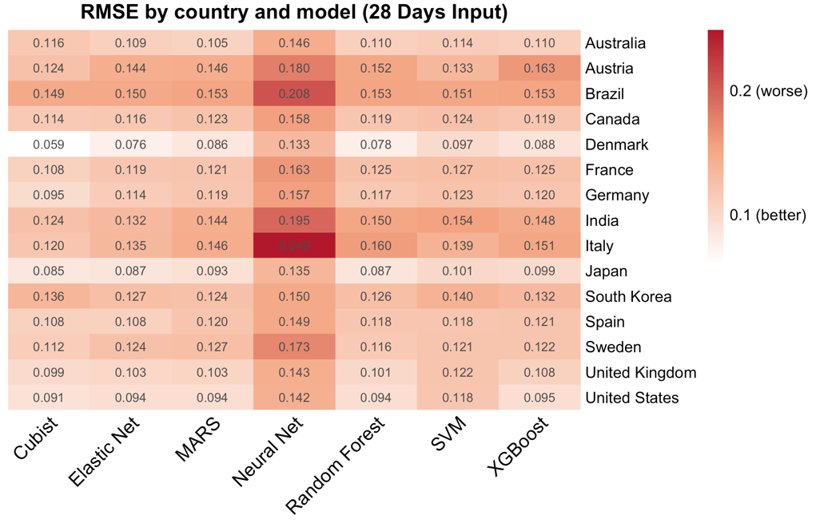
Figure 3(a). Heatmap of RMSE across models and countries for predicting monthly maximum share using a 28-day input. White= lower, red = higher; columns clustered by performance similarity.

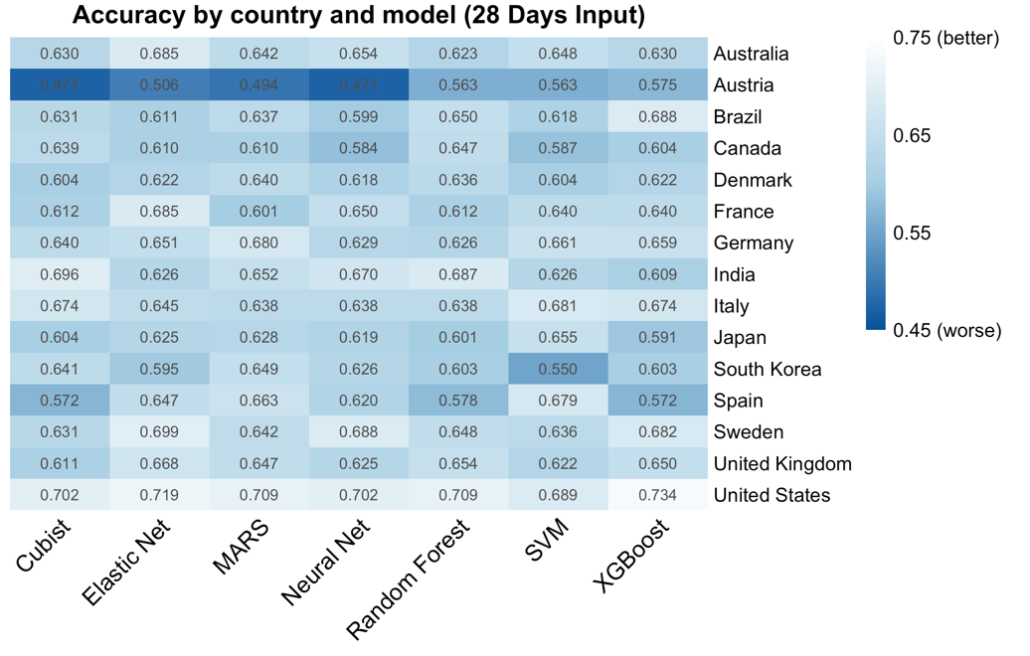
Figure 3(b). Heatmap of accuracy across models and countries for predicting monthly maximum share using a 28-day input. Blue = lower, white = higher; columns clustered by performance similarity.

Figure 3 (a) and (b) compares model performance for predicting variant dominance across 15 countries using 28-day inputs. RMSE captures average error in peak share prediction (lower is better), while accuracy reflects correct classification of dominance duration (higher is better). For monthly peak share (Figure 3a), Cubist, Elastic Net, and SVM consistently achieved the lowest RMSE, with the best fits in countries with dense and stable sequencing data such as Denmark, Japan, and the United States, while performance was notably weaker in Italy and Brazil where irregular sampling inflated errors. For duration above 10% share (Figure 3b), accuracy—defined as the proportion of correctly classified variants—was highest for Elastic Net, yielding strong fits in the United States (0.734), Japan (0.679), and Germany (0.661), but poorer performance in South Korea (0.550) and Austria (0.471), where shorter or more variable trajectories limited predictive stability. Collectively, these findings highlight that prediction quality varies with surveillance intensity: rule-based ensembles and margin-based classifiers fit peak outcomes best in well-sampled settings, while regularized regression offers the most robust duration predictions, albeit with reduced accuracy in countries with sparse data.

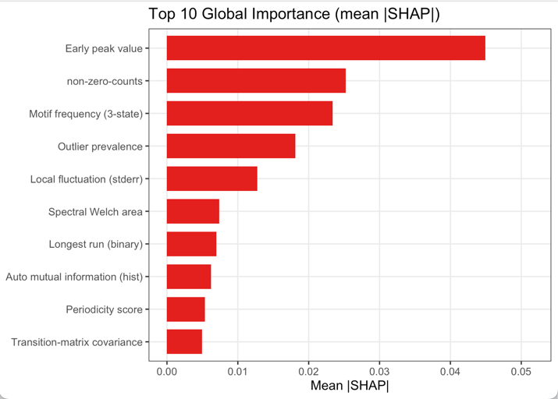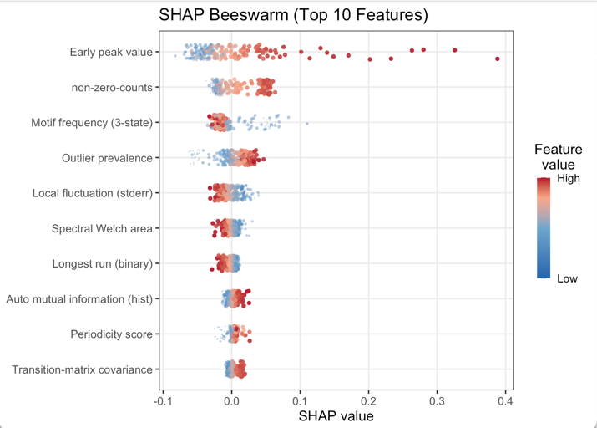
Figure 4 (a). SHAP values from the Cubist model (28-day input) for predicting variant monthly maximum peak share across 15 countries. Red indicates positive, blue negative contributions.

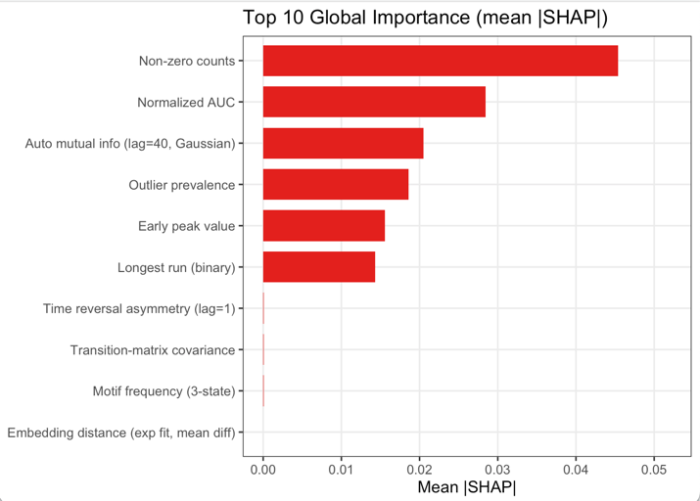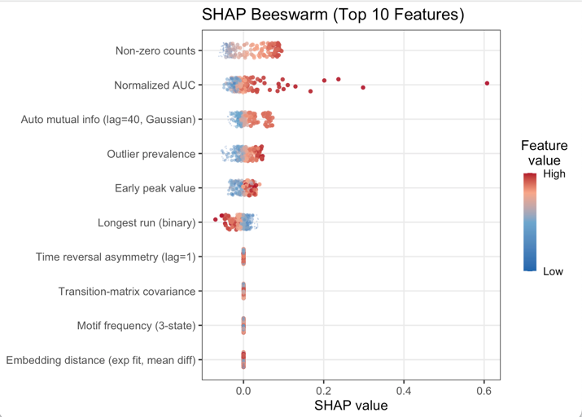
Figure 4 (b). SHAP values from the Elasticnet model (28-day input) for predicting days over 10% share across 15 countries. Red indicates positive, blue negative contributions.

SHAP analysis
Figure 4 highlights the most influential predictors driving model performance for the two dominance outcomes. For the Cubist model predicting monthly peak share (Figure 4 a), early peak value and the number of non-zero observations emerged as the strongest determinants, indicating that the initial height and persistence of early trajectories are critical signals of eventual dominance. Additional features such as motif frequency, outlier prevalence, and measures of local fluctuation or periodicity contributed secondary but consistent information, capturing subtle structural properties of early growth dynamics. (Appendix Table XX)

For the Elastic Net model predicting duration above 10% share (Figure 4 b), non-zero counts and normalized AUC dominated feature importance, suggesting that both the density and cumulative magnitude of early presence are central to explaining sustained prevalence. Other features, including measures of temporal dependence (e.g., autocorrelation and time asymmetry) and structural sequence descriptors, provided supplementary predictive power. Together, these findings underscore that while both outcomes rely on early intensity and persistence signals, peak share prediction emphasizes sharp early surges, whereas duration prediction is more sensitive to cumulative and sustained presence in the early stage.

Comparison of model prediction and observed dominant variants
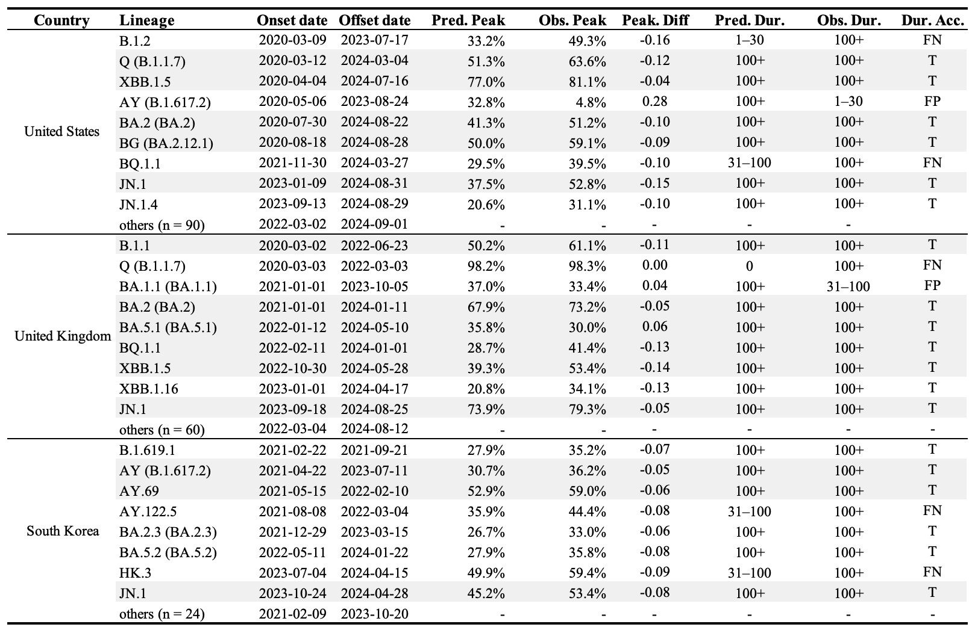
Table 3. Comparison of observed and predicted variant dominance in selected countries, defined as duration ≥100 days and peak >30%. Variants with both outcomes correctly predicted (i.e., duration ≥100 as ≥100 or <100 as <100, and peak >30% as >30% or <30% as <30%) are highlighted in grey.

The table provides a detailed breakdown of how the model performs under our operational definition of dominance (peak share > 30% and duration > 100 days). For each country, only variants that were either dominant in observation or predicted to be dominant are displayed. This filtering makes the table a compact view of key outcomes: false positives, false negatives, and correctly identified dominant variants. Variants absent from the table correspond to the large group of “not dominant and correctly predicted as not dominant.”

Across the three countries, model performance showed both consistency and variation. In the United States, where nine variants were evaluated, dominance was captured with relatively high accuracy (72%) and low peak RMSE (0.08), though notable false negatives included AY (B.1.617.2) and BQ.1.1. The United Kingdom presented six variants, with two errors (a false positive for BA.1.1 and a false negative for BQ.1.1), yielding moderate accuracy (69%) and RMSE (0.09). By contrast, South Korea proved more challenging: several Omicron sublineages such as AY.122.5 and HK.3 were underestimated, resulting in lower accuracy (51%) and higher RMSE (0.13). Taken together, these findings suggest that while the model generally underscored true dominance, its performance was stronger in larger, more comprehensively sampled epidemics (e.g., the U.S.) and weaker where trajectories were shorter or more variable (e.g., South Korea).

Taken together, these results show that while the model consistently captures the broad landscape of dominance, it errs more often on the side of underestimation, leading to more false negatives (predicted non-dominant but actually dominant). This conservative bias means that the model may miss some lineages that later prove epidemiologically important, but the early signals it does capture can still provide valuable guidance for identifying variants with high potential to rise to dominance.

Discussion

This study demonstrates that machine learning models can reliably predict SARS-CoV-2 variant dominance using only early-stage growth characteristics, achieving high predictive accuracy within 2-4 weeks of initial variant detection. Our two-stage framework successfully forecasted peak prevalence with R² values ranging from 0.63 to 0.90 across three countries, while time-to-dominance predictions maintained median absolute errors of approximately 7 days—representing a substantial improvement over current short-term forecasting approaches that typically provide only 2–3 weeks projections. Tree-based ensemble methods, particularly Random Forest and XGBoost, consistently outperformed linear, kernel-based, and other machine learning approaches, effectively capturing the complex nonlinear dynamics inherent in variant competition and growth patterns. The identification of optimal surveillance windows—16 days for the UK, 21 days for the US, and 25 days for South Korea—reveals that the critical information for dominance prediction is concentrated within the earliest weeks of variant emergence, after which additional data provides diminishing predictive value. These findings establish a practical framework for transforming genomic surveillance from reactive monitoring to proactive early warning, enabling public health authorities to anticipate variant dominance approximately one month in advance and implement targeted interventions before widespread community transmission occurs.

Our early‐stage feature‐extraction framework builds on prior efforts to anticipate variant trajectories by systematically characterizing the first weeks of emergence. Whereas earlier studies have relied primarily on raw growth curves or single indicators such as initial doubling time [11], [12], we extend these approaches by deriving a compact set of ten summary features—spanning level, variability, acceleration, and temporal persistence—that together capture the nuanced dynamics of each lineage’s rise. By anchoring our early window to the first N days after 1% prevalence, we avoid the noise of sporadic early detections and align our inputs with the point at which true community transmission begins. This design choice, coupled with fixed windows of 14, 21, or 28 days, parallels recent work on outbreak early‐warning [13], but further refines it by filtering out already‐dominant lineages and focusing exclusively on those still in growth phase Our results demonstrate that these multivariate early indicators substantially improve both peak‐share and time‐to‐dominance predictions, offering public health authorities a more reliable toolkit for real‐time risk assessment and resource allocation than methods based on single‐metric thresholds alone.

Our systematic model comparison also demonstrated that tree-based methods—namely Random Forest and XGBoost—outperformed other machine-learning approaches (such as support vector machines, LASSO regression, and shallow neural networks) when forecasting both peak prevalence and time-to-dominance from the same early-stage feature set. This superiority likely reflects the ability of ensemble trees to automatically capture nonlinear interactions among the ten-summary metrics—such as abrupt share increases, variance shifts, and intermittent zero-share runs—that linear and kernel-based models struggle to represent without extensive feature engineering. These results mirror recent findings in infectious-disease forecasting [14], where tree ensembles consistently achieved lower error rates and greater robustness under limited training data. By validating the efficacy of tree-based learners in the context of SARS-CoV-2 variant emergence, our study reinforces the growing consensus that ensemble decision-tree frameworks offer a practical, high-performance solution for real-time epidemic intelligence—particularly when rapid, early-stage predictions are required for public‐health planning.

Our results indicate that the critical window for accurately forecasting time‐to‐dominance (TTD) is confined to the first three to four weeks after a variant first exceeds 1 % domestic share. Beyond this early‐stage period, extending the fitting window yields negligible improvements in predictive accuracy, suggesting that the bulk of informative growth dynamics is captured within those initial weeks. This finding aligns with outbreak early‐warning frameworks in other pathogens—for example, influenza strain replacement models have shown that the first four weeks of case accrual carry most of the signal needed for peak‐timing forecasts [15], [16]. In the SARS-CoV-2 context, Volz et al. [10] and Davies et al. [17] similarly noted diminishing returns when fitting logistic curves beyond one month of data. By formally quantifying this “sweet spot”—four weeks for U.S. variants and three weeks for U.K. variants—our study provides a concrete guideline for real‐time surveillance systems: public‐health authorities can prioritize model updates on only the earliest four weeks of growth, thereby expediting actionable insights without sacrificing accuracy.

Additional studies corroborate how surveillance intensity and sampling strategies influence early‐trajectory stability. For example, the COVID‐19 Genomics UK (COG-UK) Consortium’s analyses demonstrated that rapid, high‐density sequencing in England captured fine‐scale shifts between Alpha and Delta variants, yielding volatile prevalence estimates in the first two weeks that only stabilized after three to four weeks of data accumulation [1]. In contrast, national‐scale genomic surveys in the United States—while broader in scope—tended to smooth out local surges, enabling reliable logistic midpoints within two weeks [18], [19]. Moreover, Volz et al.[10] showed that denser sampling grids reduce uncertainty in growth‐rate estimates, explaining why the U.K.’s punctuated sequencing cadence temporarily increased variance. Together, these findings reinforce our observation that the U.K. requires a slightly longer early window—three weeks versus two—to average out its more jagged variant signals before achieving stable time‐to‐dominance forecasts.

Several limitations should be considered when interpreting our results. First, our analysis is fundamentally constrained by the quality and representativeness of GISAID data. Sampling biases from inconsistent testing, prioritized case selection (e.g., travelers, severe cases), and reporting delays can distort early growth signals, leading to inaccurate variant trajectories and affecting model performance. Global genomic surveillance heterogeneity—differing in sequencing intensity, data quality, and sharing practices—exacerbates these challenges. Furthermore, our strict data inclusion criteria (e.g., ≥100 sequences/week) excluded many regions, particularly early in the pandemic, which limits the scope and generalizability of our findings. Second, our model focuses on sequence only data and did not incorporate genomic information to assess intrinsic characteristics like immune evasion or severity. It is reactive, designed to predict the competitive spread of variants that have already emerged rather than forecasting the de novo emergence of a future variant. Additionally, our feature extraction pipeline does not capture key epidemiological factors—such as population immunity, vaccination coverage, behavioral responses, or interactions among co-circulating variants—that may influence variant competitiveness. Model performance also varied substantially across countries: for example, while we observed high R² values in the United States (0.64) and South Korea (0.62), performance in the United Kingdom was markedly lower (0.63), suggesting that differences in surveillance strategies, population structure, and social mixing patterns may impact predictive validity. Third, like many other models, there is a gap in translating these frequency predictions into forecasts of absolute public health impact, such as the number of hospitalizations or deaths a variant will cause. Closing this gap is a critical next step for ensuring such predictions can be more directly integrated into public health planning.

Our study systematically evaluates multiple SARS-CoV-2 variants across fifteen countries, delivers interpretable, country-specific TTD estimates to guide booster rollouts and non-pharmaceutical interventions. This unified pipeline—from data preprocessing to model validation— is adaptable to other pathogens like influenza or RSV for proactive epidemic preparedness. Future work could enhance this framework through a two-pronged approach. First, integrating unsupervised anomaly scores from wastewater or clinical samples could provide more robust early warnings, especially in low-coverage settings. Second, combining our tree-based ensemble with genomic risk scores (like HiRisk or MLAEP) would create a unified pipeline. This expanded model could then address whether any emerging variantst become dominant, and how severe will its impact be in a specific region, enabling proactive public health responses.

Conclusion
This study presents a robust machine learning framework for early prediction of SARS-CoV-2 variant dominance, demonstrating that tree-based models can accurately forecast both peak prevalence and time-to-dominance using only the first 2-4 weeks of growth data after a variant reaches 1% domestic share. With prediction accuracies achieving R² values up to 0.60 and time-to-dominance estimates within approximately 7 days of actual outcomes, our two-stage approach provides public health authorities with a practical tool for proactive surveillance and resource allocation. The identification of optimal surveillance windows—16 days for the UK, 21 days for the US, and 25 days for South Korea—offers concrete guidance for real-time genomic monitoring systems, enabling rapid assessment of emerging variants before they achieve widespread circulation. Beyond immediate pandemic applications, this framework establishes a foundation for broader respiratory pathogen surveillance, potentially enhancing preparedness for future seasonal influenza waves, respiratory syncytial virus outbreaks, and novel coronavirus emergence. By transforming reactive surveillance into predictive intelligence, this data-driven approach represents a significant advancement in epidemic preparedness infrastructure, offering the potential to mitigate the impact of both established and emerging respiratory pathogens through earlier intervention and more targeted public health responses.

[1] L. du Plessis et al., “Establishment and lineage dynamics of the SARS-CoV-2 epidemic in the UK,” Science, vol. 371, no. 6530, pp. 708–712, Feb. 2021, doi: 10.1126/science.abf2946.
[2] W. H. Organization, “SARS-CoV-2 genomic sequencing for public health goals: interim guidance, 8 January 2021,” Art. no. WHO/2019-nCoV/genomic_sequencing/2021.1, 2021, Accessed: July 16, 2025. [Online]. Available: https://iris.who.int/handle/10665/338483
[3] C. Chen et al., “CoV-Spectrum: analysis of globally shared SARS-CoV-2 data to identify and characterize new variants,” Bioinforma. Oxf. Engl., vol. 38, no. 6, pp. 1735–1737, Mar. 2022, doi: 10.1093/bioinformatics/btab856.
[4] “Tracking SARS-CoV-2 variants.” Accessed: July 16, 2025. [Online]. Available: https://www.who.int/activities/tracking-SARS-CoV-2-variants
[5] E. B. Hodcroft et al., “Spread of a SARS-CoV-2 variant through Europe in the summer of 2020,” Nature, vol. 595, no. 7869, pp. 707–712, July 2021, doi: 10.1038/s41586-021-03677-y.
[6] A. Rambaut et al., “A dynamic nomenclature proposal for SARS-CoV-2 lineages to assist genomic epidemiology,” Nat. Microbiol., vol. 5, no. 11, pp. 1403–1407, Nov. 2020, doi: 10.1038/s41564-020-0770-5.
[7] Á. O’Toole et al., “Assignment of epidemiological lineages in an emerging pandemic using the pangolin tool,” Virus Evol., vol. 7, no. 2, p. veab064, 2021, doi: 10.1093/ve/veab064.
[8] Re3data.Org, “GISAID,” 2012, re3data.org - Registry of Research Data Repositories. doi: 10.17616/R3Q59F.
[9] B. D. Fulcher, M. A. Little, and N. S. Jones, “Highly comparative time-series analysis: The empirical structure of time series and their methods,” J. R. Soc. Interface, vol. 10, no. 83, p. 20130048, June 2013, doi: 10.1098/rsif.2013.0048.
[10] E. Volz et al., “Assessing transmissibility of SARS-CoV-2 lineage B.1.1.7 in England,” Nature, vol. 593, no. 7858, pp. 266–269, May 2021, doi: 10.1038/s41586-021-03470-x.
[11] R. Karimi et al., “Basic Reproduction Number (R0), Doubling Time, and Daily Growth Rate of the COVID-19 Epidemic: An Echological Study,” Arch. Acad. Emerg. Med., vol. 12, no. 1, p. e66, Sept. 2024, doi: 10.22037/aaem.v12i1.2376.
[12] A. Anzai and H. Nishiura, “Doubling time of infectious diseases,” J. Theor. Biol., p. 111278, Sept. 2022, doi: 10.1016/j.jtbi.2022.111278.
[13] L. Zhang, M. Li, C. Zhi, M. Zhu, and H. Ma, “Identification of Early Warning Signals of Infectious Diseases in Hospitals by Integrating Clinical Treatment and Disease Prevention,” Curr. Med. Sci., vol. 44, no. 2, pp. 273–280, Apr. 2024, doi: 10.1007/s11596-024-2850-x.
[14] H.-L. Zheng, S.-Y. An, B.-J. Qiao, P. Guan, D.-S. Huang, and W. Wu, “A data-driven interpretable ensemble framework based on tree models for forecasting the occurrence of COVID-19 in the USA,” Environ. Sci. Pollut. Res. Int., vol. 30, no. 5, p. 13648, Sept. 2022, doi: 10.1007/s11356-022-23132-3.
[15] V. C et al., “Demonstrating the use of high-volume electronic medical claims data to monitor local and regional influenza activity in the US,” PloS One, vol. 9, no. 7, July 2014, doi: 10.1371/journal.pone.0102429.
[16] C. Reed et al., “Estimates of the prevalence of pandemic (H1N1) 2009, United States, April-July 2009,” Emerg. Infect. Dis., vol. 15, no. 12, pp. 2004–2007, Dec. 2009, doi: 10.3201/eid1512.091413.
[17] N. G. Davies et al., “Estimated transmissibility and impact of SARS-CoV-2 lineage B.1.1.7 in England,” Science, vol. 372, no. 6538, p. eabg3055, Apr. 2021, doi: 10.1126/science.abg3055.
[18] X. Deng et al., “Genomic surveillance reveals multiple introductions of SARS-CoV-2 into Northern California,” Science, vol. 369, no. 6503, pp. 582–587, July 2020, doi: 10.1126/science.abb9263.
[19] T. Bedford et al., “Cryptic transmission of SARS-CoV-2 in Washington state,” Science, vol. 370, no. 6516, pp. 571–575, Oct. 2020, doi: 10.1126/science.abc0523.

Appendix
The data processing workflow consisted of four sequential stages. First, we loaded SARS-CoV-2 genomic surveillance data from GISAID, spanning 26,152 lineages across 15 countries (Stage 0). Country-specific analytical periods were then applied to remove early sparse sampling and late low-volume reporting, yielding 24,286 analytical variants (Stage 1: Data Filtering). Next, variants were aggregated using a parent-rule criterion, resulting in 874 lineage groups across countries (Stage 2: Data Grouping). A pre-filtering step excluded observations before a 1% share was reached, after which model-ready datasets were generated by extracting 2–5 weeks of early variant trajectories as predictors and pairing them with two dominance outcomes: monthly peak share and duration above 10% share (Stage 3: Model Data Generation).

Figure S1. Overview of the data processing workflow, including data inclusion, exclusion, and grouping steps.

Data Flow (According to Figure S1)
This table extends Table 1 by providing year-by-year summaries of the raw Pango lineages sampled within each country. It reports both the total number of cases available for genomic analysis and the five most prevalent lineages in each year, highlighting the shifts from early ancestral and Alpha/Delta lineages to successive Omicron subvariants.
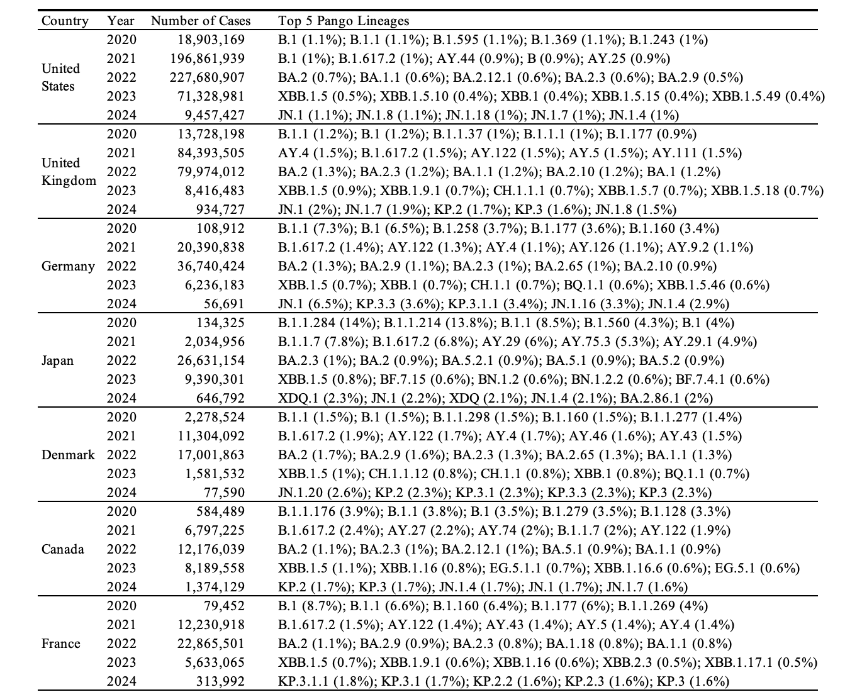
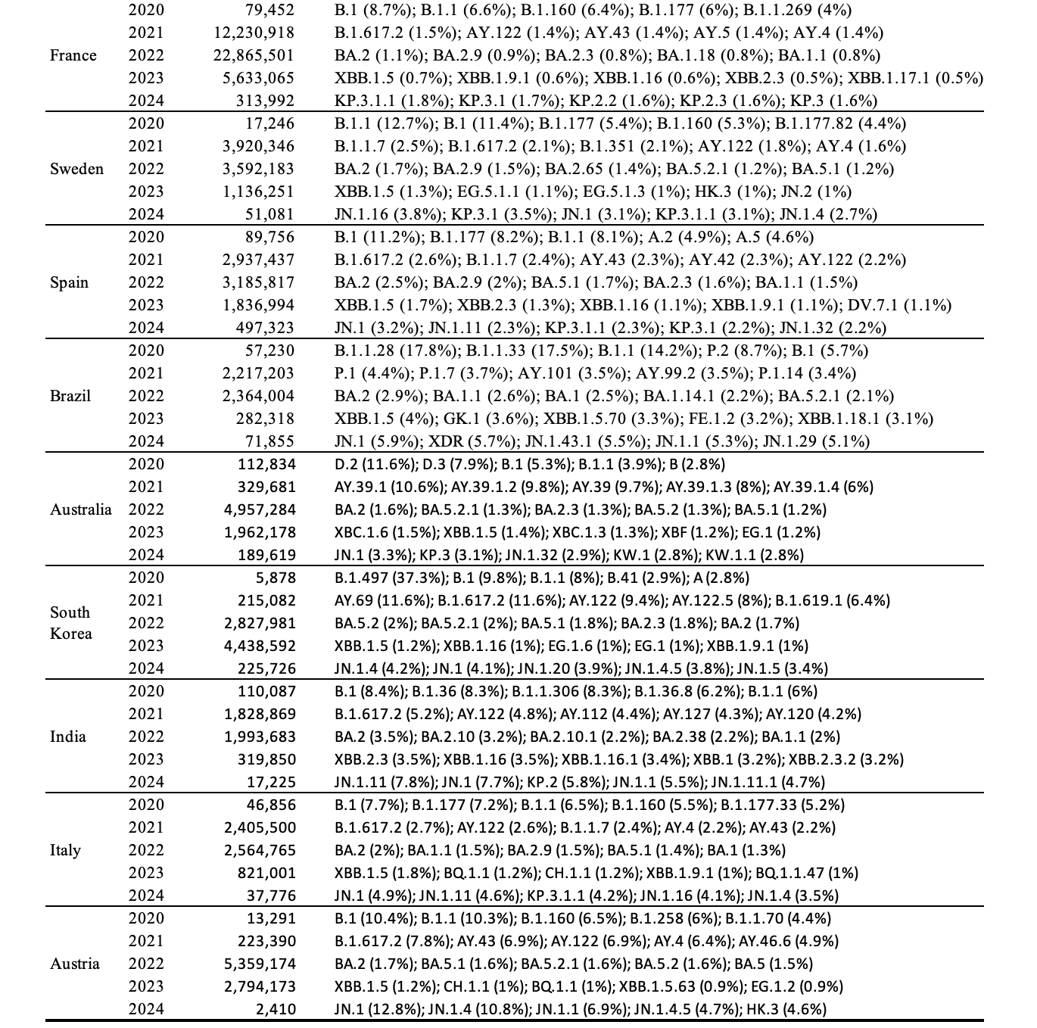
Table S1: Descriptive summary of GASID data showing the distribution of raw PANGO lineages in all top 15 countries.

Data Processing
Figure S1 illustrates the analytical periods defined in Stage 1 of the data workflow, indicated by the two vertical blue lines. Within these boundaries, daily reported COVID-19 cases (black dots) are plotted to reflect the total denominators available for variant analysis. Across countries, the analytical periods are generally aligned to cover the major epidemic waves while excluding early sparse reporting and late low-case periods. For example, countries with sustained surveillance and larger case counts (e.g., United States, United Kingdom, Germany) have broader analytical windows, while countries with smaller denominators (e.g., Austria, Australia, South Korea) show narrower periods, ensuring that analysis is performed during intervals of reliable case volume.
Figure S2: Analytical periods (blue vertical lines) defined for the 15 study countries, overlaid on their sequencing denominators across time.

These three panels illustrate the major SARS-CoV-2 variants from the United States (Figure S2a), the United Kingdom (Figure S2b), and South Korea (Figure S2c) that were excluded from the analytical period. For each country, the six variants with the largest overall sample volumes were selected for display. As shown, these variants either circulated primarily before the onset of the analytical period (e.g., B.1, B.1.1) or after its end (e.g., KP.3.1.1, JN.1.16), and thus fell outside the defined analytical scope. This corresponds to the earlier description of the analytical period: the dashed blue vertical lines mark the study window, and variants outside this interval were excluded.
Figure S3 (a): Main SARS-CoV-2 variants from the United States in the GISAID dataset that were excluded from the analytical scope.
Figure S3 (b): Main SARS-CoV-2 variants from the United Kingdom in the GISAID dataset that were excluded from the analytical scope.
Figure S2 (c): Main SARS-CoV-2 variants from the South Korea in the GISAID dataset that were excluded from the analytical scope.

Table S2 summarizes excluded variants across countries at different input windows (14–35 days), showing at which stage they failed to meet inclusion criteria. Variants were excluded either because they had already surpassed 30% share during the window or never reached 1%, with check marks indicating the reason for exclusion.
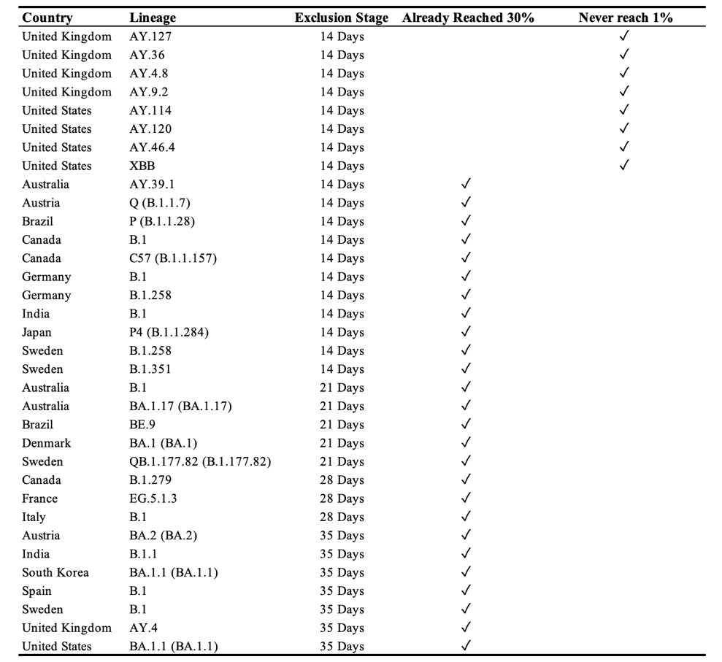
Table S2: List of excluded variants in different number of input days modeling and the reason to be excluded.

Feature Extraction
We extracted two complementary sets of features from the lineage time-series data.
Manual features (epidemiologically motivated):
• Log-linear slope: Growth or decline trend estimated from the log-transformed time series.
• Short-window slopes: Early growth rates estimated from the first k days (e.g., 7 days).
• Peak value: Maximum observed share in the time window.
• Normalized area under the curve (AUC): Average prevalence across the time window.
• Longest increasing run: Maximum number of consecutive days with strictly increasing values.
• Non-zero count: Number of days with non-zero observed share.

catch22 features (statistically motivated, 22 canonical time-series descriptors):
Distributional properties
1. DN_HistogramMode_5: Mode of z-scored distribution using 5 bins.
2. DN_HistogramMode_10: Mode of z-scored distribution using 10 bins.
3. DN_OutlierInclude_p_001_mdrmd: Median distance including upper-tail outliers (>0.1%).
4. DN_OutlierInclude_n_001_mdrmd: Median distance including lower-tail outliers (<0.1%).

Autocorrelation and temporal dependence
5. CO_AutoCorr_1: Autocorrelation coefficient at lag 1.
6. CO_FirstMin_ac: First minimum of the autocorrelation function.
7. CO_f1ecac: First minimum of the embedded autocorrelation function.
8. IN_AutoMutualInfoStats_40_gaussian_fmmi: First minimum of automutual information (lag ≤40).

Time irreversibility and asymmetry
9. CO_trev_1_num: Numerical time irreversibility statistic.
10. CO_trev_1_raw: Raw time irreversibility measure.

Spectral properties
11. SP_Summaries_welch_rect_area_5_1: Area under Welch power spectrum in low-frequency band.
12. SP_Summaries_welch_rect_centroid: Spectral centroid using Welch periodogram.

Local model and forecast error
13. FC_LocalSimple_mean1_tauresrat: Ratio of mean to residual variance in a simple local model.
14. FC_LocalSimple_mean3_stderr: Standard error from a 3-point local simple forecast.

Embedding and nonlinear dynamics
15. CO_Embed2_Dist_tau_d_expfit_meandiff: Exponential fit of mean differences in 2D embedding distances.
16. CO_Embed2_Dist_tau_d_expfit_meandiff2: Variant of embedding distance statistic.

Heart-rate variability analogues (variability of successive changes)
17. MD_hrv_classic_pnn40: Proportion of successive differences >40% of the standard deviation.
18. MD_hrv_classic_pnn50: Proportion of successive differences >50% of the standard deviation.

Motif and binary sequence patterns
19. SB_BinaryStats_mean_longstretch1: Longest run of consecutive positive or negative values.
20. SB_TransitionMatrix_3ac_sumdiagcov: Covariance of diagonal entries in a 3-state transition matrix.
21. SB_MotifThree_quantile_hh: Quantile-based statistic of three-point motifs.

Periodicity
22. PD_PeriodicityWang_th0_01: Periodicity measure based on Wang’s thresholded statistic.

Together, these manual and catch22 features capture both epidemiologically meaningful summaries of growth and prevalence as well as diverse statistical, spectral, nonlinear, and motif-based characteristics of the time series.

Machine Learning Methods
Elastic Net (EN)
Elastic Net regression (Zou & Hastie, 2005) is a linear modeling approach that combines L1 (lasso) and L2 (ridge) regularization. It is particularly effective in settings with many correlated predictors, as it can both shrink coefficients to stabilize estimates and perform variable selection. In our context, EN provides an interpretable baseline, highlighting which early features of variant growth most strongly predict dominance outcomes.

Random Forest (RF)
Random Forests (Breiman, 2001) are ensemble models that aggregate predictions from multiple decision trees grown on bootstrap samples of the data. By averaging across trees and sampling predictor subsets at each split, RF reduces overfitting and captures nonlinear relationships between features. This makes it well suited to modeling complex epidemic trajectories where interactions between early signals may drive variant success.

Gradient Boosting Machine (GBM) and XGBoost (XGB)
Boosting methods such as GBM (Friedman, 2001) and XGBoost (Chen & Guestrin, 2016) sequentially build trees, with each new tree correcting the residual errors of the previous ensemble. These models emphasize difficult-to-predict observations, offering strong predictive performance in structured time-series tasks. XGBoost further improves computational efficiency and incorporates regularization, which enhances stability when handling high-dimensional, noisy early-stage features.

Support Vector Machine (SVM)
Support Vector Machines (Cortes & Vapnik, 1995) classify or regress by finding a hyperplane that maximizes the margin between groups. Using radial kernels, SVMs can model nonlinear separation in the predictor space. For our application, SVMs are valuable in distinguishing early trajectories of variants likely to achieve dominance from those destined to remain minor.

Multivariate Adaptive Regression Splines (MARS)
MARS (Friedman, 1991) is a nonparametric regression method that fits piecewise linear splines, allowing the model to adapt flexibly to local structures in the data. By automatically selecting knots and interactions, MARS provides a transparent yet flexible framework to capture nonlinear epidemic growth signals while maintaining interpretability.

Cubist Regression
Cubist (Quinlan, 1993) is a rule-based regression model that extends decision trees with linear regressions at the terminal nodes. This hybrid structure combines the interpretability of rules with the flexibility of local linear models, making it effective in capturing both threshold-like behaviors and continuous growth trends in variant dynamics.

Overall model performance based on 15 countries GISAID data.
For the prediction of monthly maximum share, Cubist consistently outperformed other methods, with RMSE declining from 0.113 at 14 days to 0.097 at 35 days and R² rising from 0.704 to 0.754. Support Vector Machines and XGBoost also delivered competitive performance, particularly with shorter input horizons, while neural networks lagged behind across all settings. These results indicate that rule-based ensemble methods and margin-based classifiers are well suited to capturing the nonlinear dynamics of peak dominance, and that longer early-stage windows provide clearer growth signals for continuous prediction.

For the prediction of duration above 10% share, Elastic Net regression showed the best overall performance, achieving the highest accuracy (0.701) and macro-F1 (0.682) with 35 days of input. Other ensemble methods such as Random Forests and XGBoost performed comparably but did not surpass Elastic Net, underscoring the strength of regularized linear models in handling categorical outcomes with imbalanced distributions. Overall, the findings highlight that different outcomes favor different modeling strategies: Cubist is optimal for continuous peak prediction, while Elastic Net is best suited for categorical dominance duration, with performance improving consistently as the length of the early observation period increases.
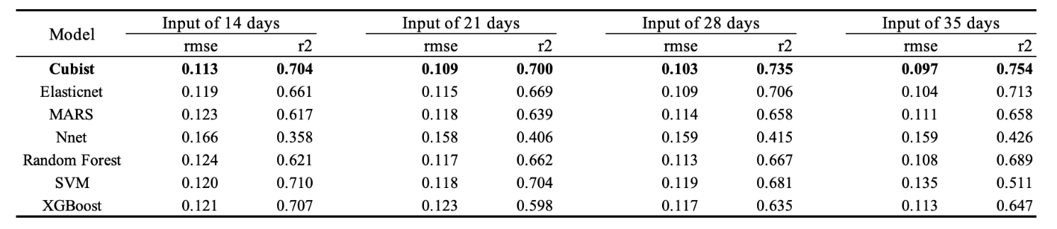
Table S3 (a). Model performance for predicting the Monthly Maximum Share.

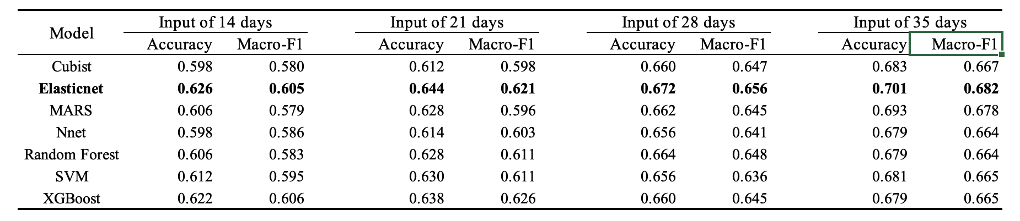
Table S3 (b). Model performance for predicting the Time over 10% share.

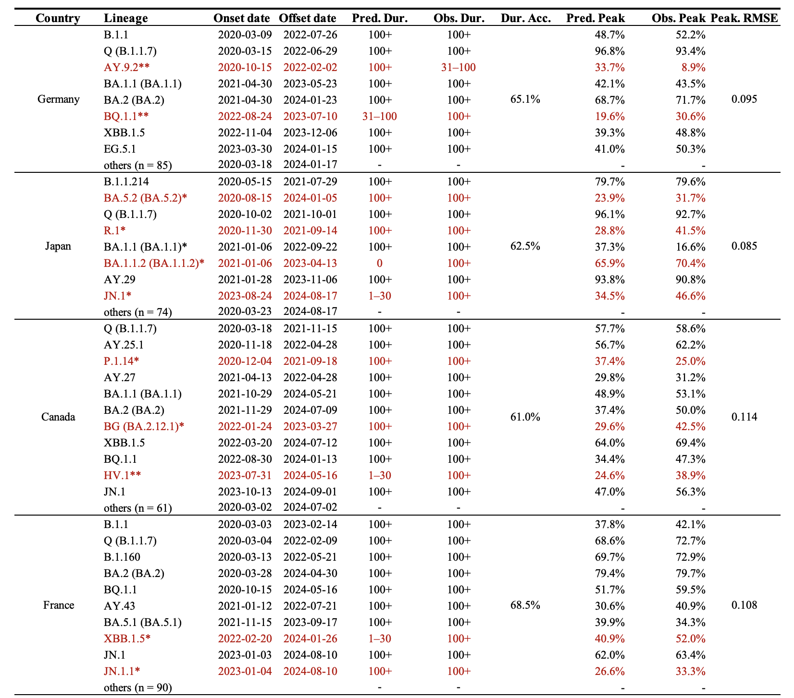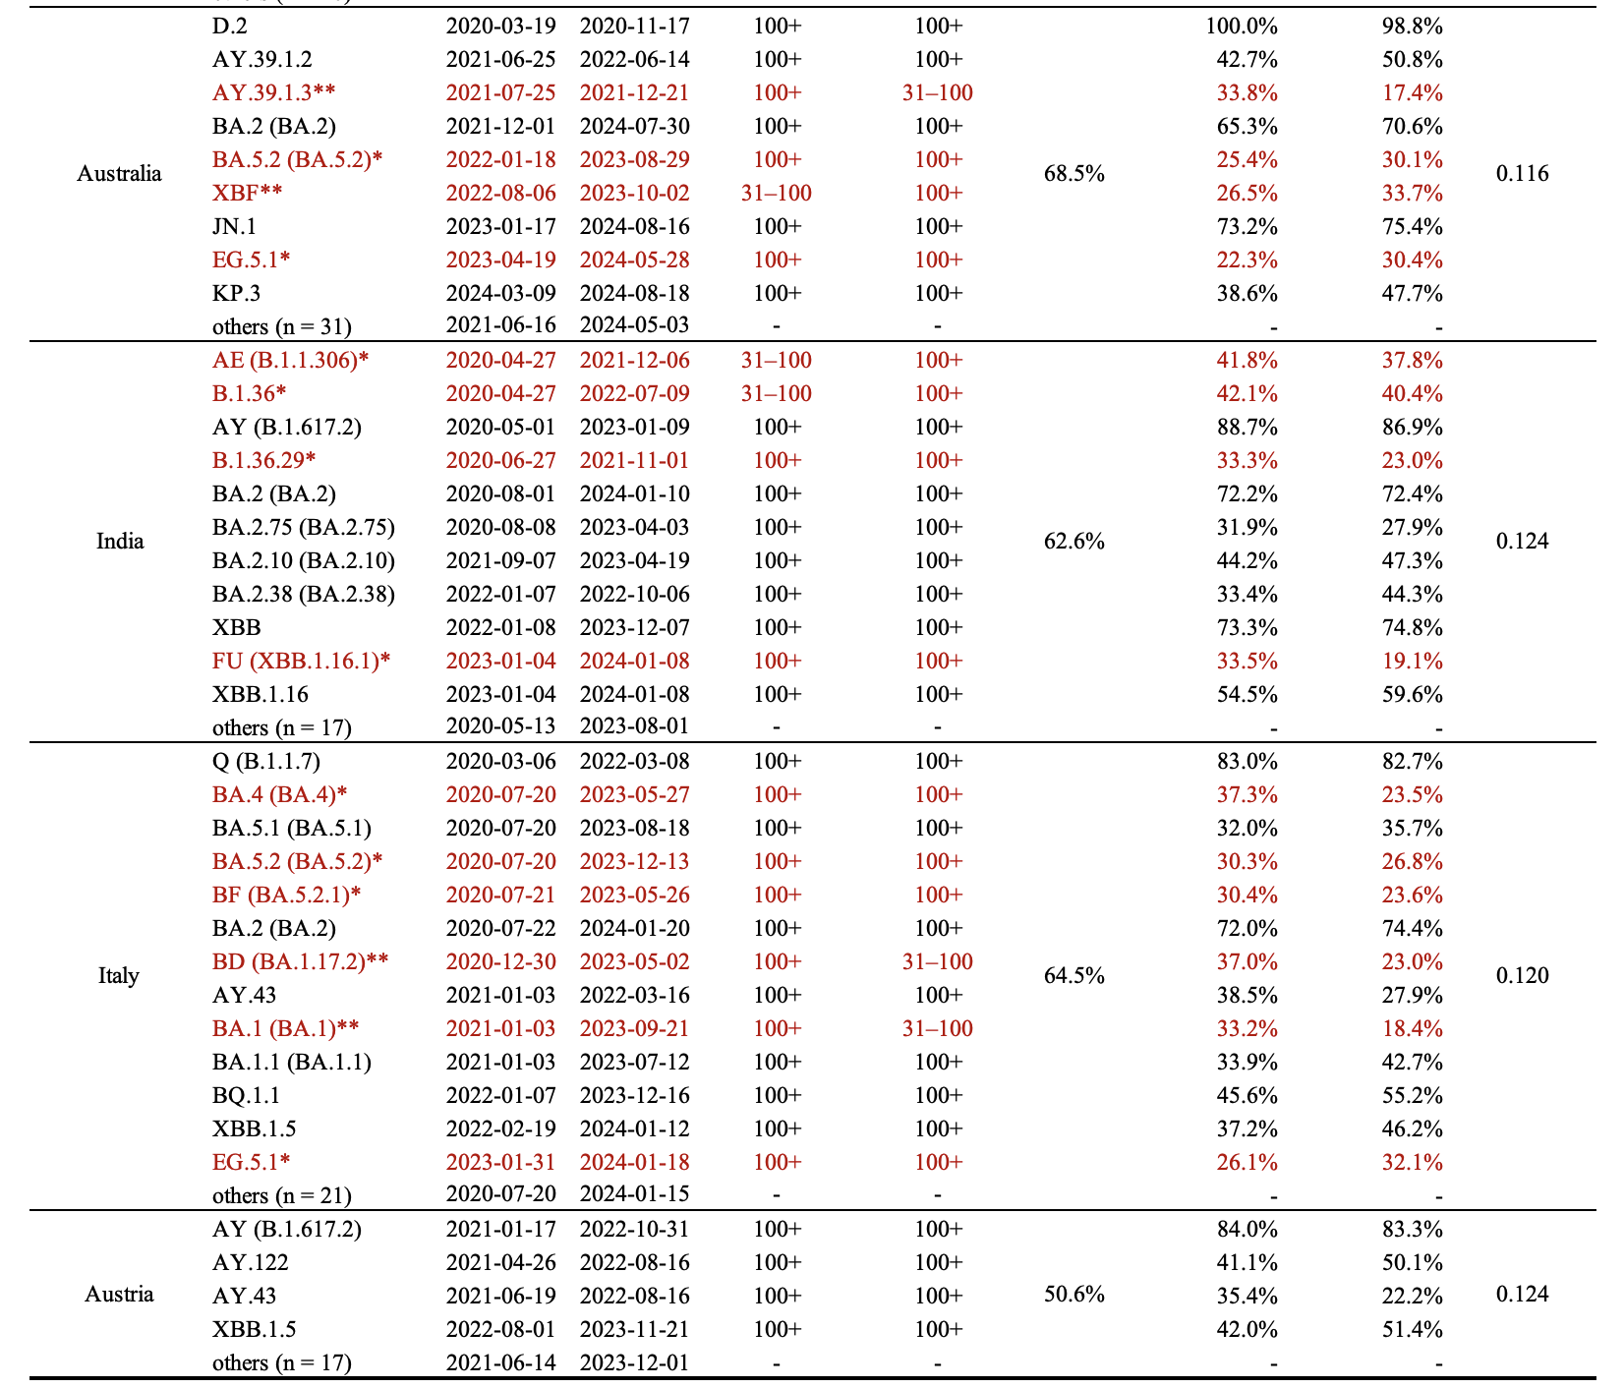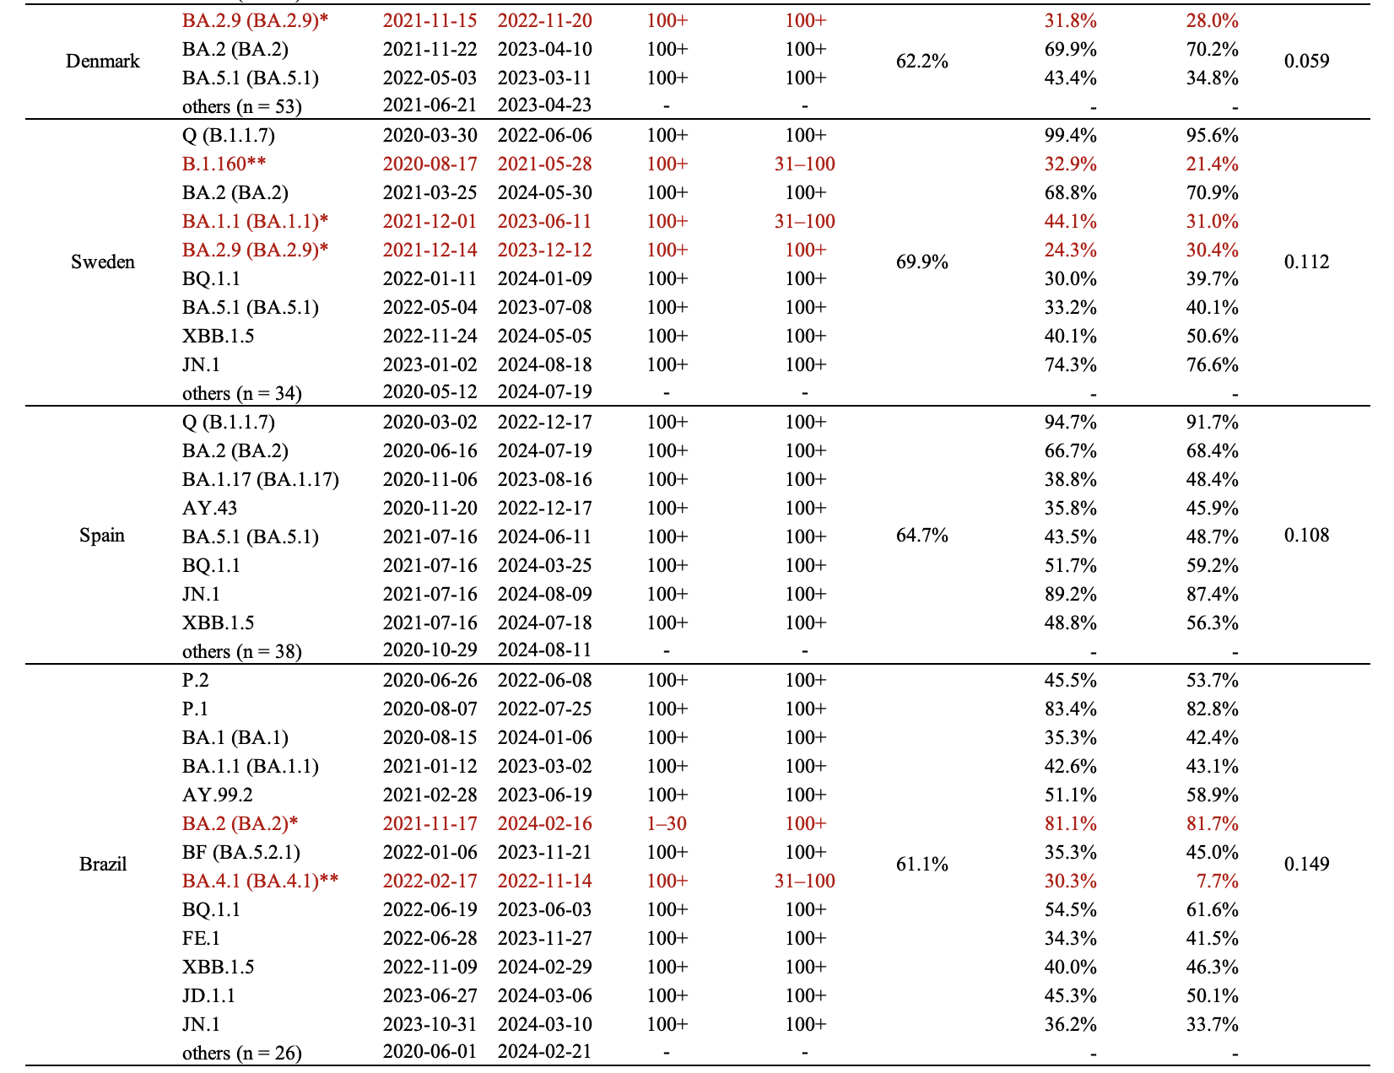
Table S4. Comparison of observed and predicted variant dominance of the rest 12 countries. Dominance was defined as duration ≥100 days and peak prevalence >30%. Variants highlighted in red indicate prediction errors: a single asterisk (*) denotes misclassification in either peak or duration, while a double asterisk (**) denotes misclassification in both outcomes. The “others” category includes all remaining lineages within each country that were consistently non-dominant and correctly predicted as such.

